报告题目  Title | Artificial Intelligence in Automotive Security: Emerging Threats and Intrusion Detection
摘 要  Abstract | AI has shown a rapid development race with a promising usage in automotive domain. The automotive domain has realized amazing advancements in communication, connectivity, and automation—and at a breakneck pace. Such advancements come with ample benefits, such as the reduction of traffic accidents and the refinement of transit efficiency. However, these new developments (e.g., AI-assisted services) were not necessarily made with security in mind. This talk will first introduce the automotive background and the application of AI techniques. The talk then will present the potential attack vectors and introduce existing solutions, especially intrusion detection methods and new CAN datasets for evaluation. In the end, this talk will summarize the open challenges in this domain.
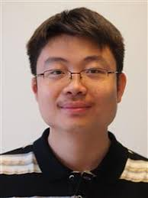

Bio:
Weizhi Meng is a Full Professor in the School of Computing and Communications, Lancaster University, United Kingdom. He was a recipient of the Hong Kong Institution of Engineers (HKIE) Outstanding Paper Award for Young Engineers/Researchers in both 2014 and 2017. He also received the IEEE ComSoc Best Young Researcher Award for Europe, Middle East, & Africa Region (EMEA) in 2020 and the IEEE HITC Award for Excellence for Middle Career Researchers in 2023. His primary research interests are cyber security, artificial intelligence in security and blockchain technology, including intrusion detection, trust management, smartphone security, biometric authentication, HCI security, and IoT security. He serves as associate editors / editorial board members for many reputed journals such as IEEE TDSC and IEEE TIFS, as well as general chair for various international conferences such as ACM CCS 2023 and ESORICS 2022. He is an ACM Distinguished Speaker.

